15.5.2022

Tässä tiedostossa teen muistiinpanoja YouTuben CrashCourse-kanavan Computer Science videoista.

Contents

1 Early Computing 3

2 Electronic Computing 4

3 Boolean Logic & Logic Gates 5

4 Representing Numbers and Letters with Binary 6

5 How Computers Calculate 7

6 Registers and RAM 8

7 The Central Processing Unit (CPU) 9

8 Instructions & Programs 10

9 Advanced CPU Designs 11

10 Early Programming 12

11 The First Programming Languages 13

12 Programming Basics 14

13 Intro to Algorithms 15

14 Data Structures 16

15 Alan Turing 17

16 Software Engineering 18

17 Integrated Circuits & Moore’s Law 19

18 Operating Systems 20

19 Memory & Storage 21

20 Files & File Systems 22

# 1 Early Computing

* Abacus: Counting frame, calculation tool, Mesopotamia, 2500 BCE
* Astrolabe, Sliderule
* Tools made it easier and faster to calculate large and hard things
* Word “Computer” comes from 1613 by Richard Braithwait. Computer was a person who does calculations.
* People used more and more machines to help them so the machine was more and more referred as a machine.
* The Step Reckoner was a machine, which could do addition, substraction, multiplication and division.
* Calculation was needed for the military. For example calculating shell projection. Range tables were used
* Charles Babbage (the fater of computing) proposed a machine called the Difference Engine, which could approximate polynomials. He wanted to build the mahcine in 1823, but it had 25 000 comonents and would have weighted 15 tons. During the construction, he imagined the Analytical Engine, general purpose computer.
* Ada Lovelace is said to be the world’s first programmer.
* Herman Hollerith, build a tabulating machine, electro-mechanical, punch cards.
* Computers were first used by scientists and mathematists, but later the businesses realized their value and started to use them as well.
* In 1924 certain machine makers became The International Business Machines Corporation (IBM)

# 2 Electronic Computing

* Harvard Mark I, 1944 by IBM for Allies
* 765 000 components
* 3 million connections
* 500 miles of wire
* 3500 relays
* 3 additions or subtractions per second
* Multiplications: 6 sec
* Divisions: 15 sec
* Trigonometric function: over 1 min
* Earliest uses: Simulations for the Manhattan Project
* Relays: Electrically-controlled mechanical switches
* Controle wire

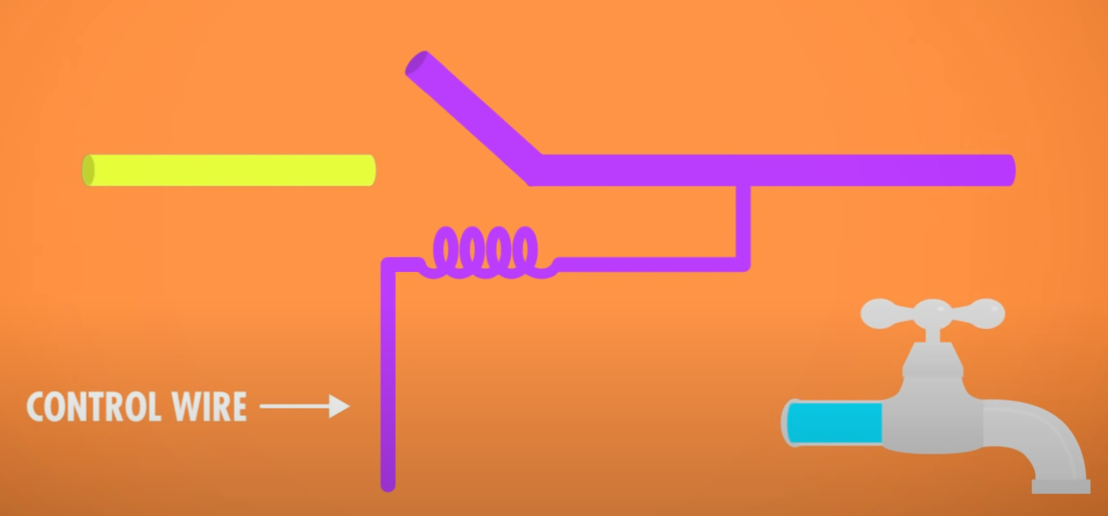

* A good relay in the 1940’s: flick back and forth 50 times/second
* 1947, Harvard Mark II, death moth
* Grace Hopper: If there is something wrong with the computer, it has bugs in it
* 1904, English physicist John Ambrose Fleming, new electrical component: a thermionic valve
* Two electrodes inside an airtight glass bulb, vacuum tube.
* One of the electrodes could be heated which would cause it to emit electrons – a process called thermionic emission. The other electrode could then attract these electrons to create the flow of our electric faucet, but only if it was positively charged. Neg, neutral charge: no attraction across the vacuum -> no current would flow
* An electronic component that permits the one-way flow of current: Diode
* 1906, American inventor Lee de Forest: added a third “control” electrode: between two electrodes in Fleming’s design
* Vacuum tubes were expensive, so transition from electromecanic to electric didn’t happen right away
* Colossus Mk 1, first large-scale use of vacuum tubes, enginner Tommy Flowers, 1943
* 1600 vacuum tubes
* The first programmable, electronic computer
* Programming: Plugging hundreds of wires into plugboards (like old school telephone switchboards)
* The Electronic Numerical Integrator and Calculator – or ENIAC, 1946, University of Pennsylvania, designed: John Mauchly and J. Presper Eckert
* First general purpose, programmable, electronic computer
* 5000 ten-digit addtiions or subtractions per second
* Operational: 10 years: Estimated to have done more arithmetic than the entire human race up to that point
* Many vacuum tubes -> failures = usually operational only about half a day
* 1950’s: vacuum-tube-based computing: limit
* The US Air Force’s AN/FSQ-7 computer, 1955, SAGE air defense computer system
* 1947, Bell Laboratory scientists John Bardeen, Walter Brattain and William Shockley: the transistor
* The physics behind transistors rely on quantum mechanics
* Just like relay or vacuum tube: open or close by applying electical power via a control wire
* Two electrodes separated by a material that sometimes can conduct electricity and other times resist it: A semiconductor

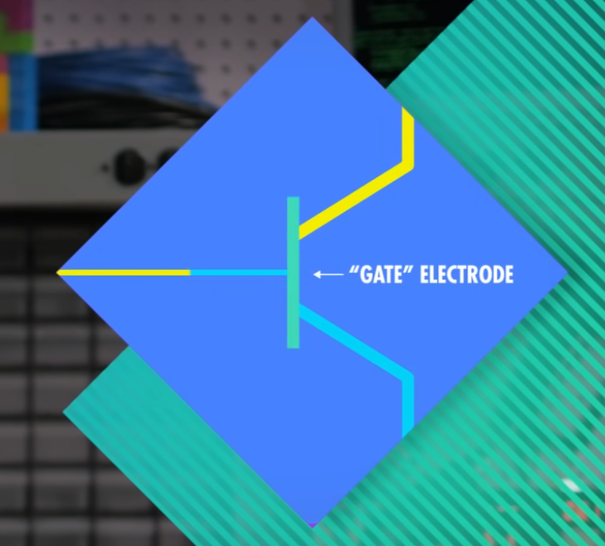

* On and off states: 10 000 times per second
* Solid state component (solid material)
* Very quickly, transistors could be made smaller than previous components
* -> Dramatically smaller and cheaper computers
* IBM 608, 1957 – the first fully transistor-powered, commercially-available computer
* 3000 transistors
* 4500 additions or 80 multiplications or divisions, every second
* Today: transistors smaller than 50 nanometers in size (a sheet of paper: 100 000 nanometers)
* The can switch states millions of times per second, run for decades
* A lot of transistor and semiconductor development, Santa Clara Valley, between San Francisco and San Jose, California -> Silicon Valley
* William Shockley moved to Silicon Valley, Shockley Semiconductor: Employees founded: Fairchild Semiconductors: Employees founded: Intel

# 3 Boolean Logic & Logic Gates

* Binary: of two states
* Some early electronic computers were ternary (3 states) and even quinary (5 states)
* Problem is to keep states separate
* One reason to use binary: The mathematics already existed for it: Boolean Algebra
* George Boole, self-taught English mathematician, 1800s
* The mathematical Analysis of Logic, 1847
* Fundamental operations in Boolean Algebra: a NOT, and AND, and an OR operation

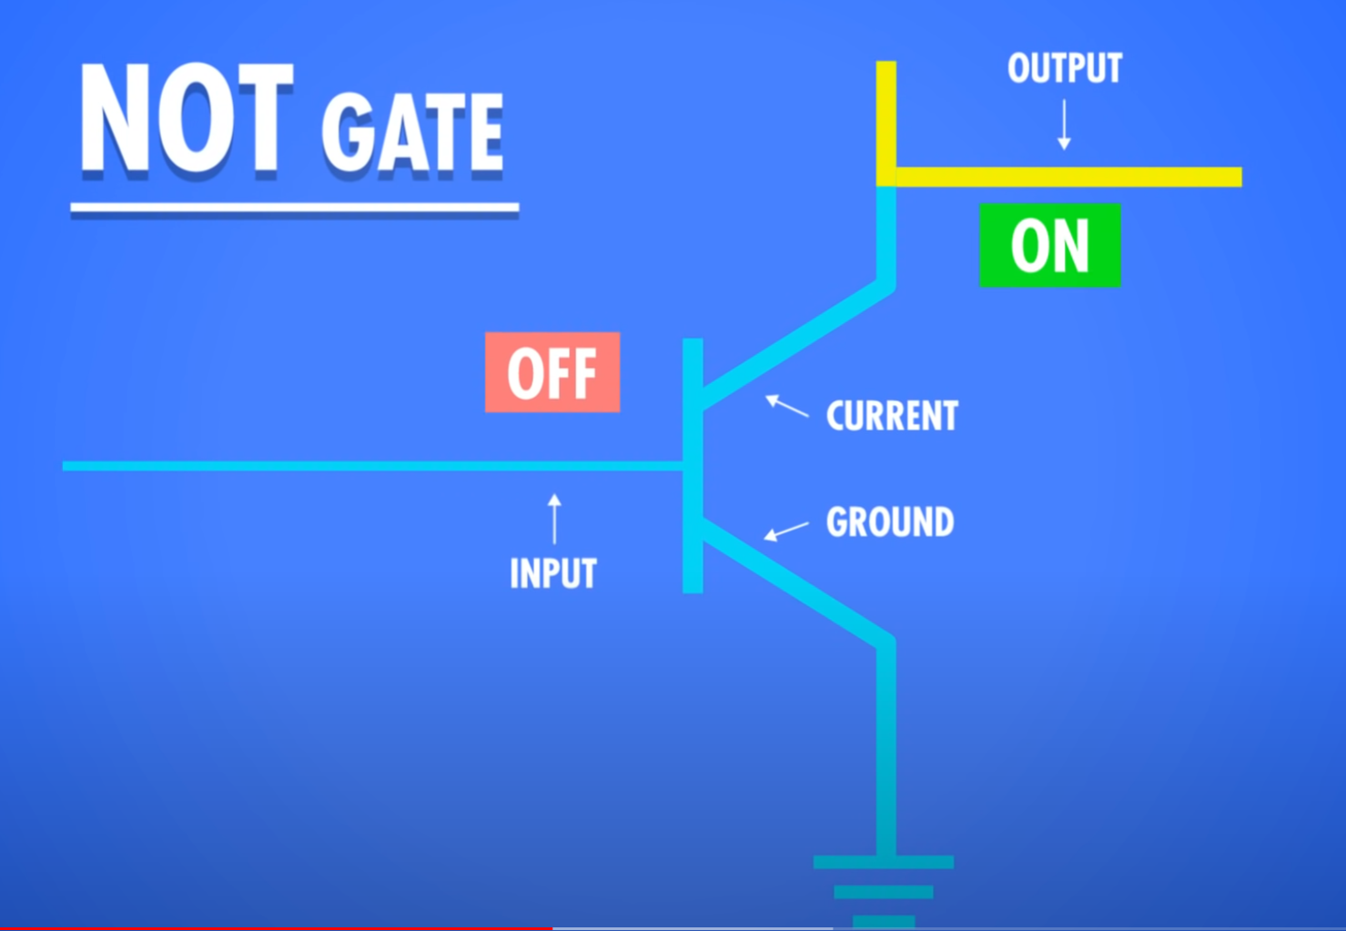

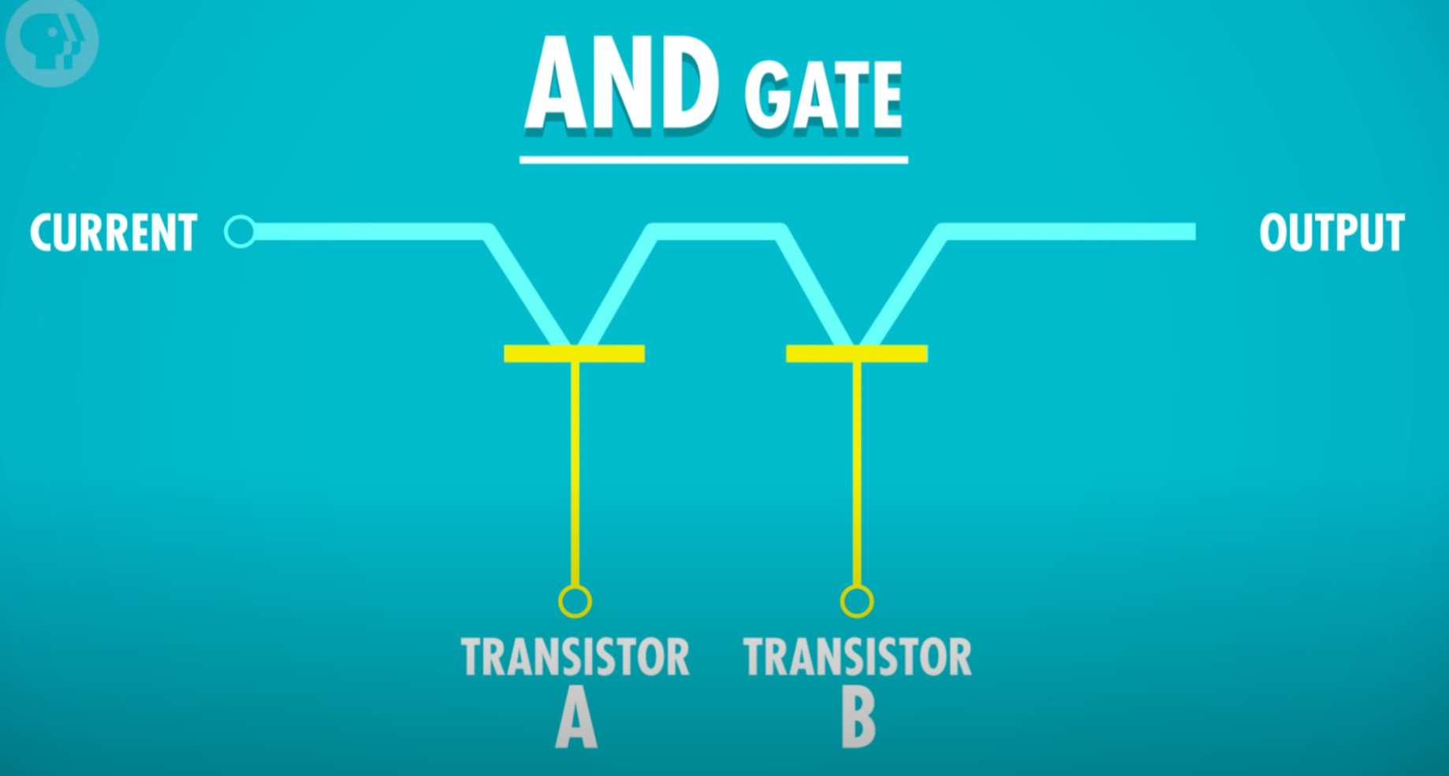

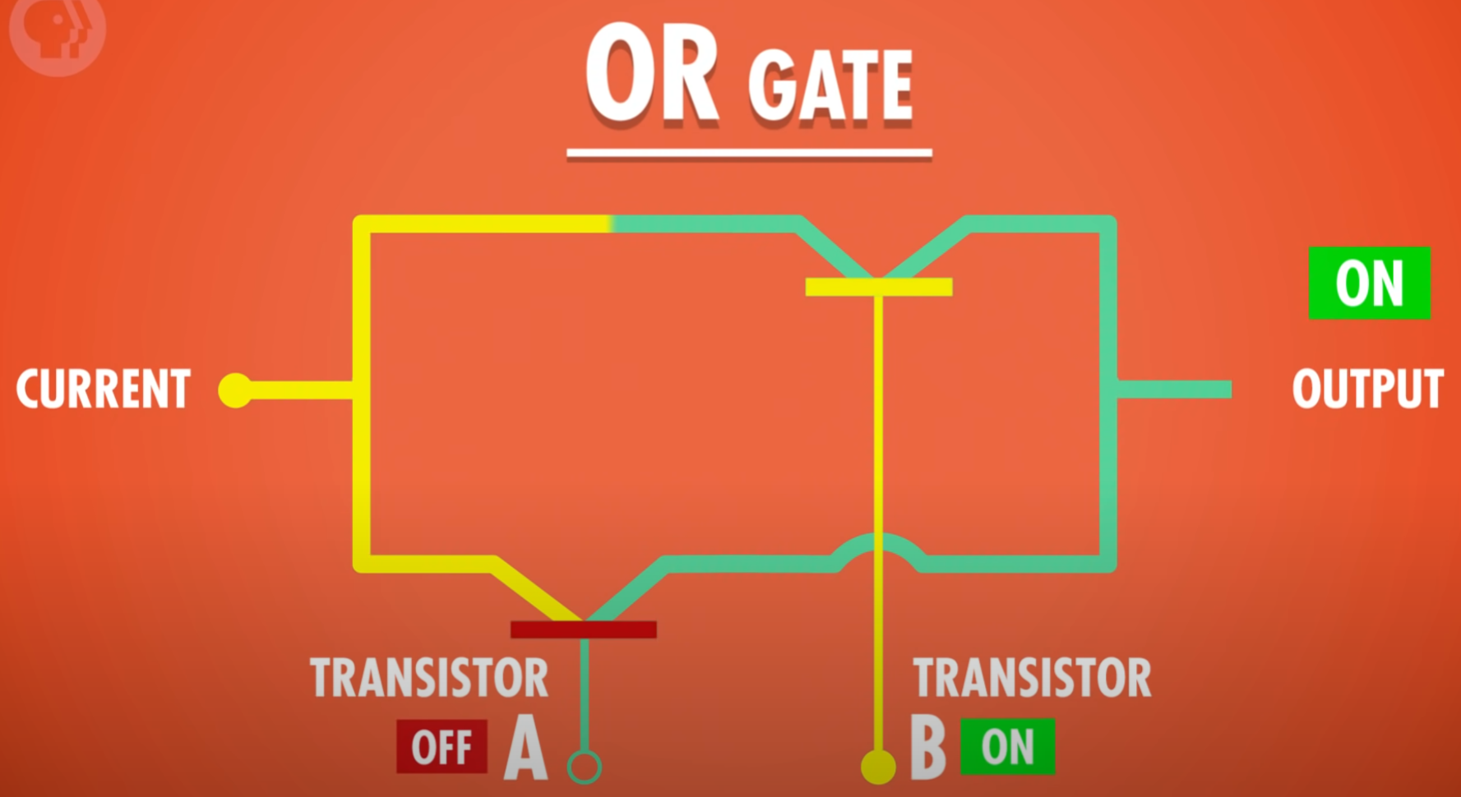

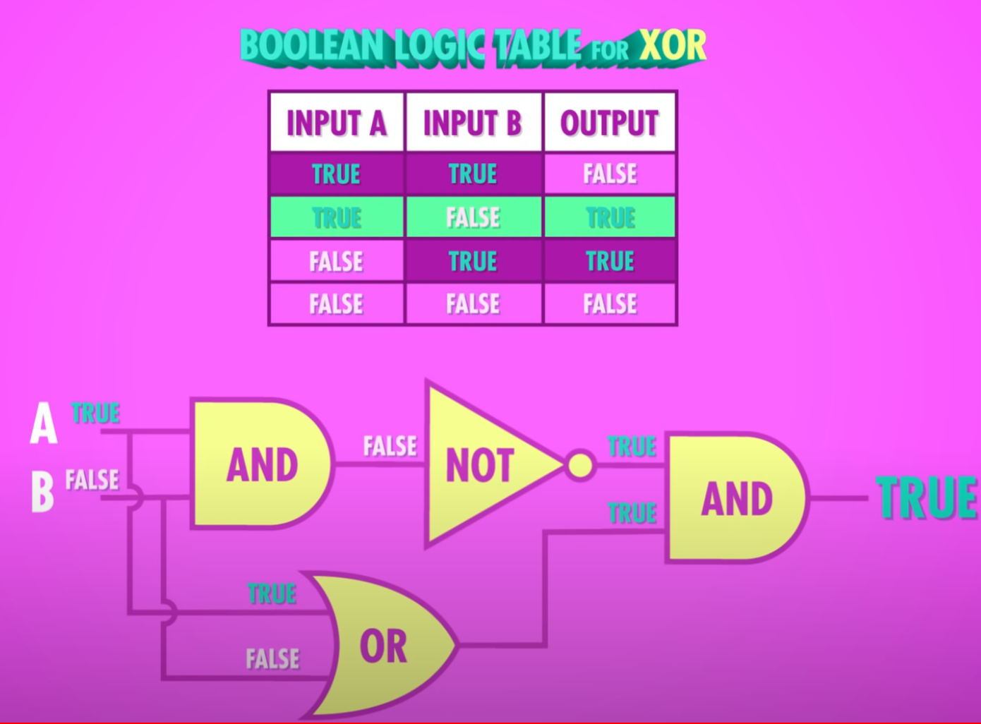

* XOR: a or b but not both

# 4 Representing Numbers and Letters with Binary

* Byte: 8 bits
* Colors for example: 8-bit vs 24-bit
* OS: 32-bit vs 64-bit

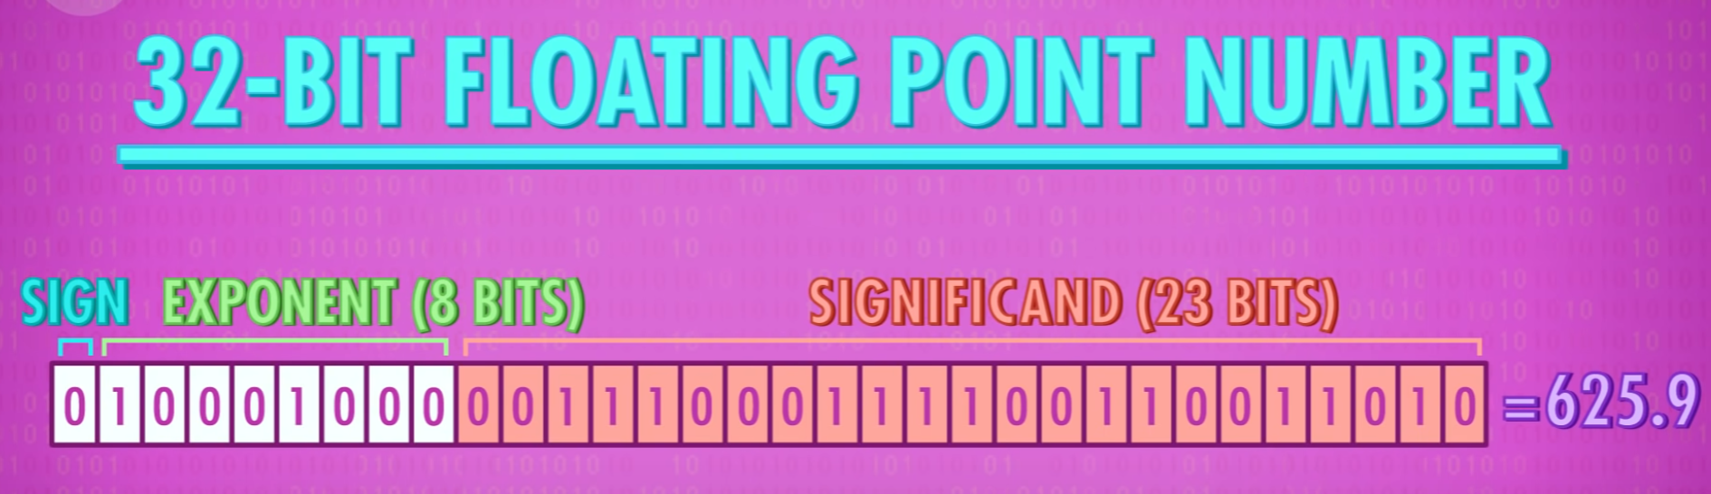

* ASCII (American Standard Code for Information Interchange)
* Interoperability: Ability to universally exchange information
* Unicode, 1992, The most common version uses 16 bits

# 5 How Computers Calculate

* ALU: Arithmetic-logic unit
* The most famous ALU ever: Intel 74181, 1970

### Arithmetic Unit

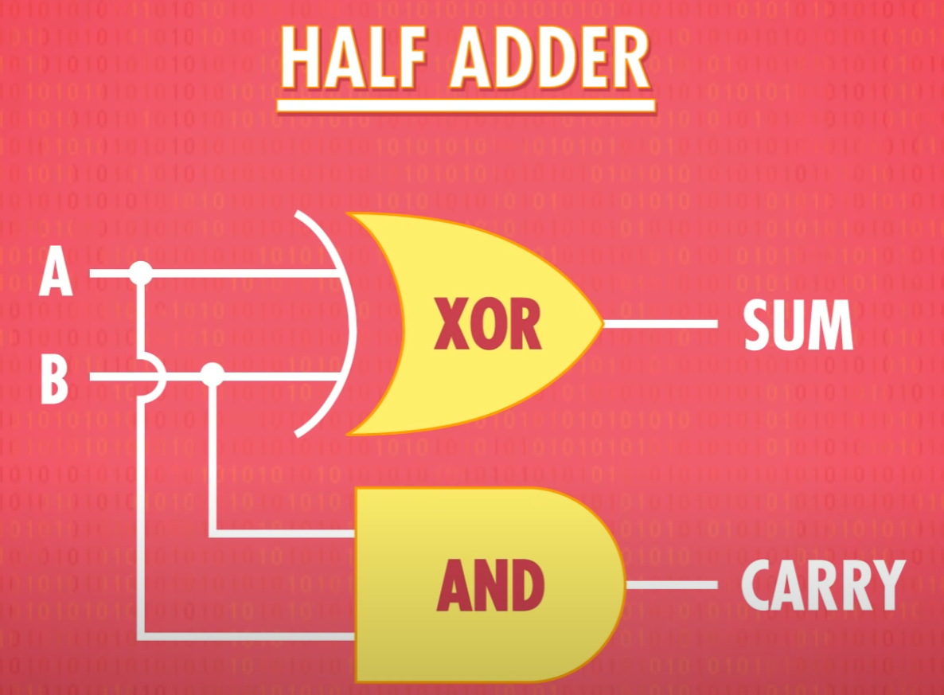

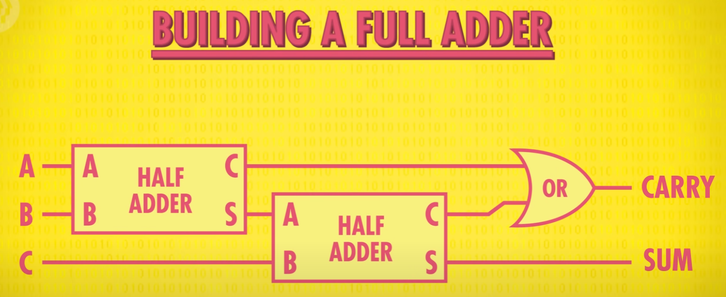

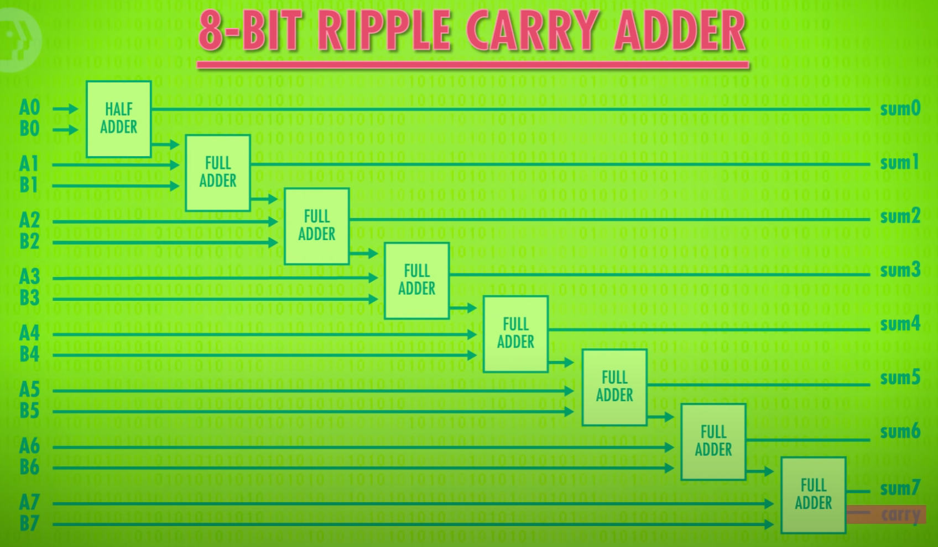

* Overflow if the last carry is 1
* Modern computers use: Carry-look-ahead adder

ALU contains: (build with individual logic gates

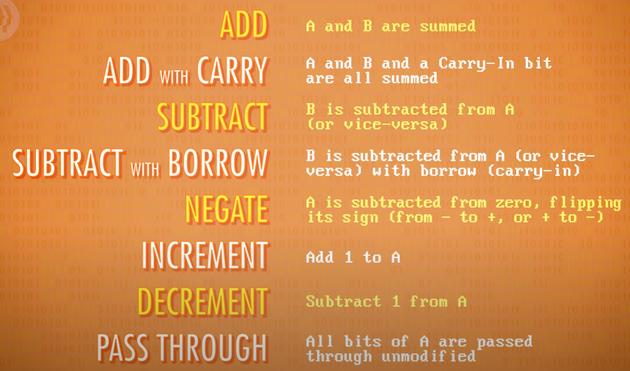

* Multiplications can be done with simple additions, but it is slow
* More advanced devices have separate logic gates for multiplications and divisions, and they are more complex.

### Logic Unit

Checks if number is over 0:

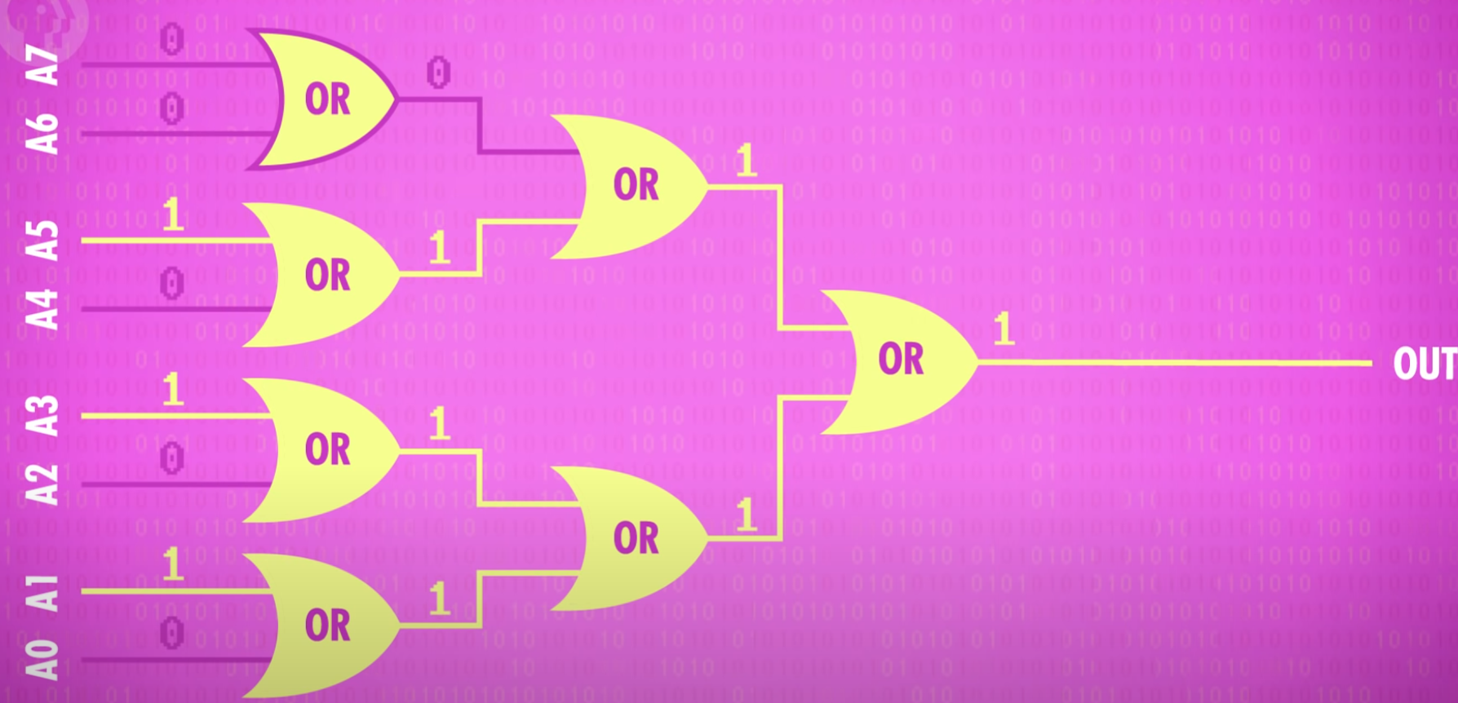

Intel 74181: (4 bits)

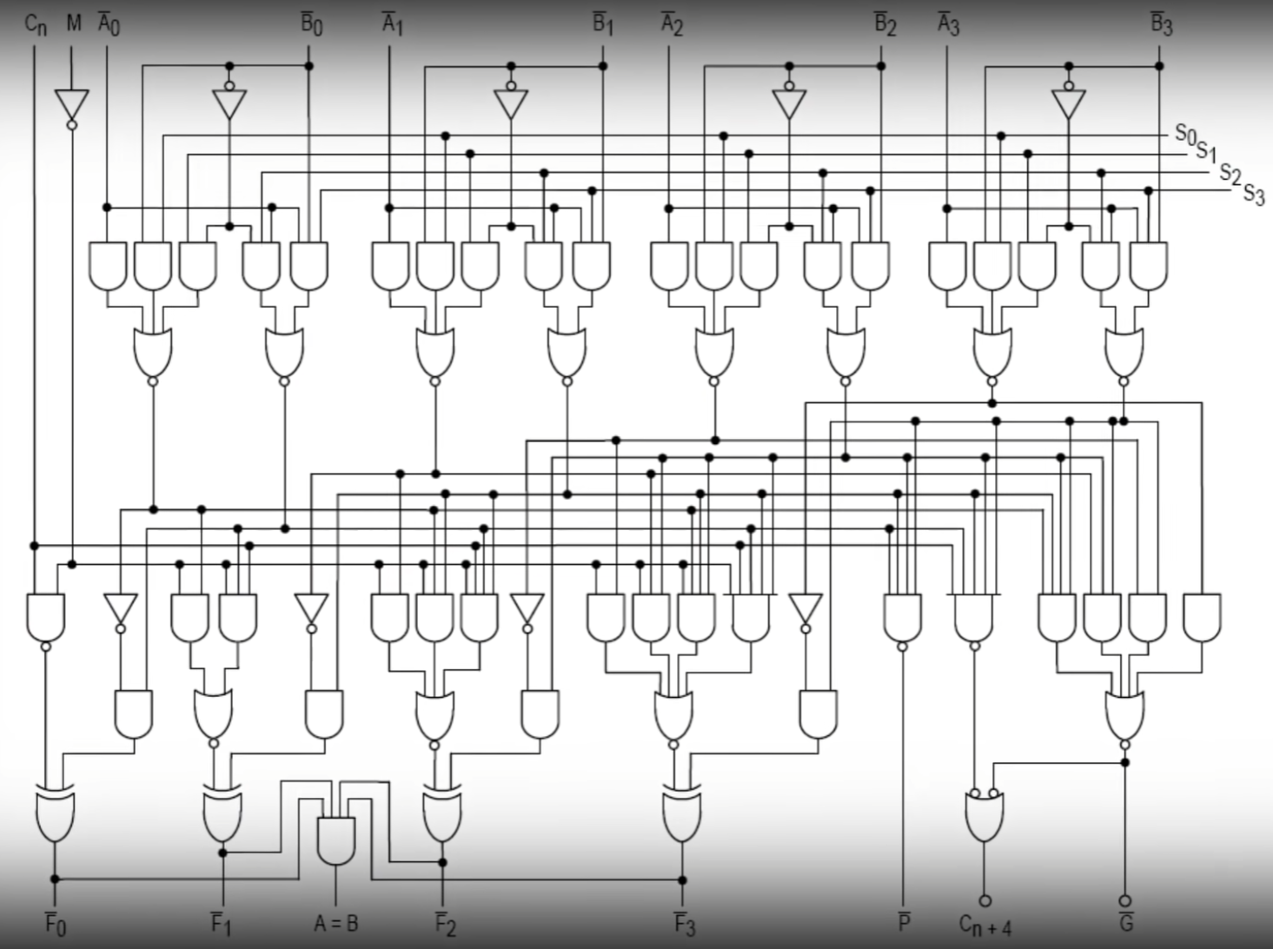

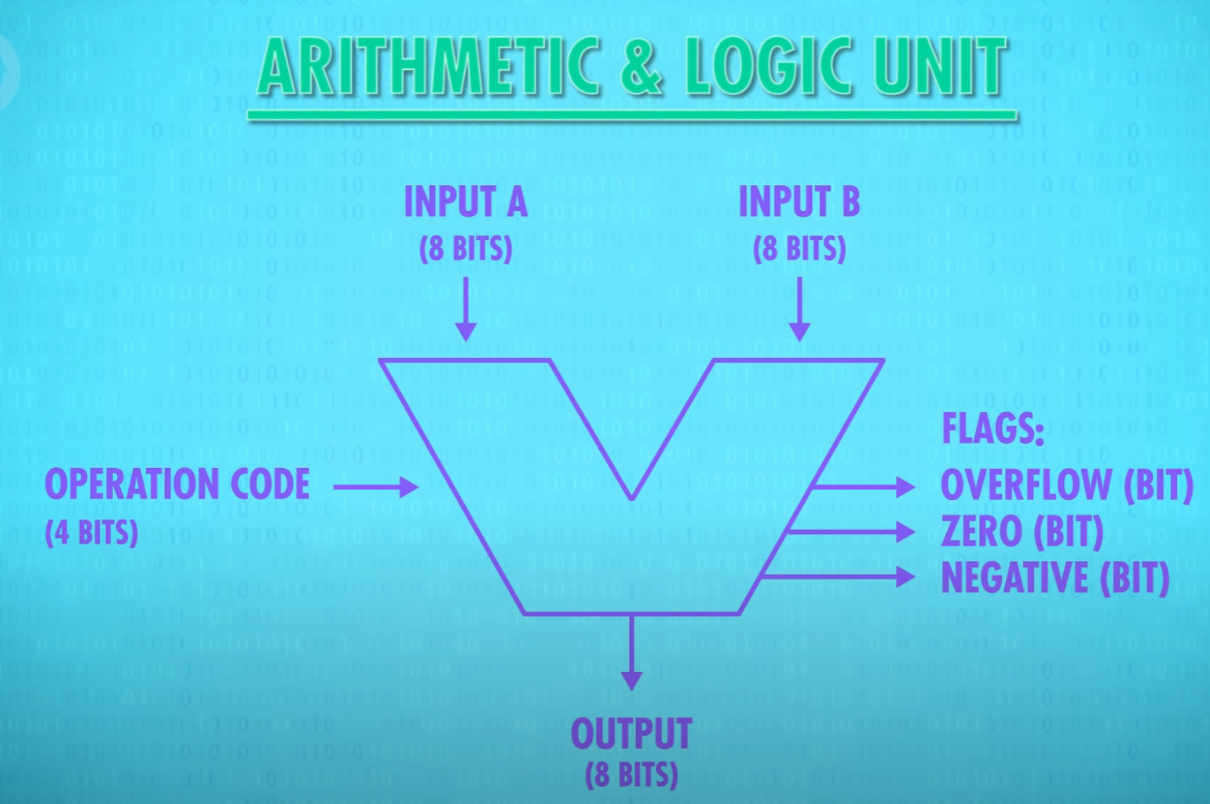

# 6 Registers and RAM

* RAM: Random Access Memory
* Presistent Memory

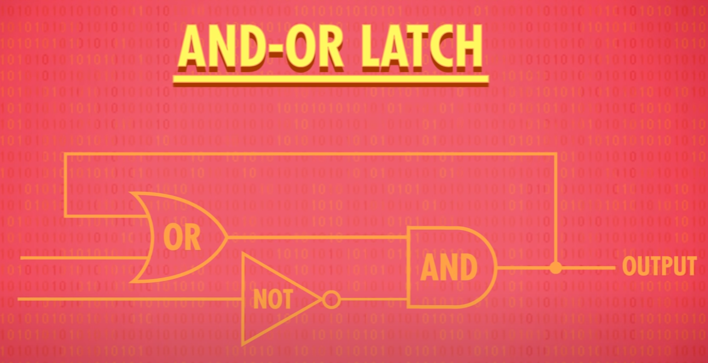

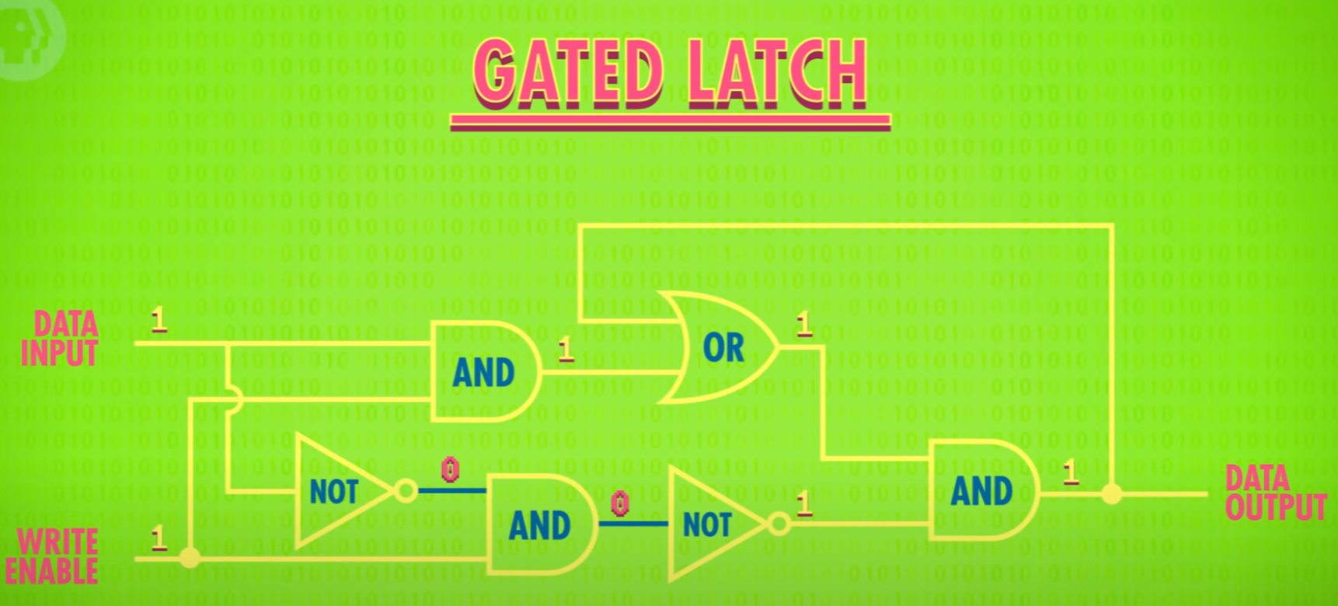

* A group of latches: Register
* Bits in a register: width
* Registers went from 8 to 16 to 32 to 64

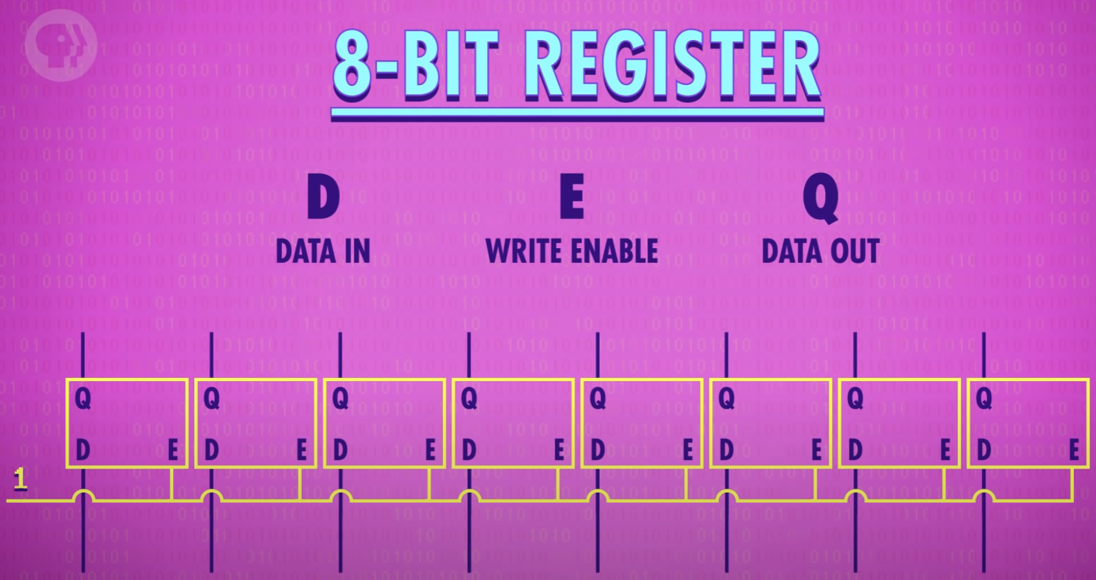

256 bits:

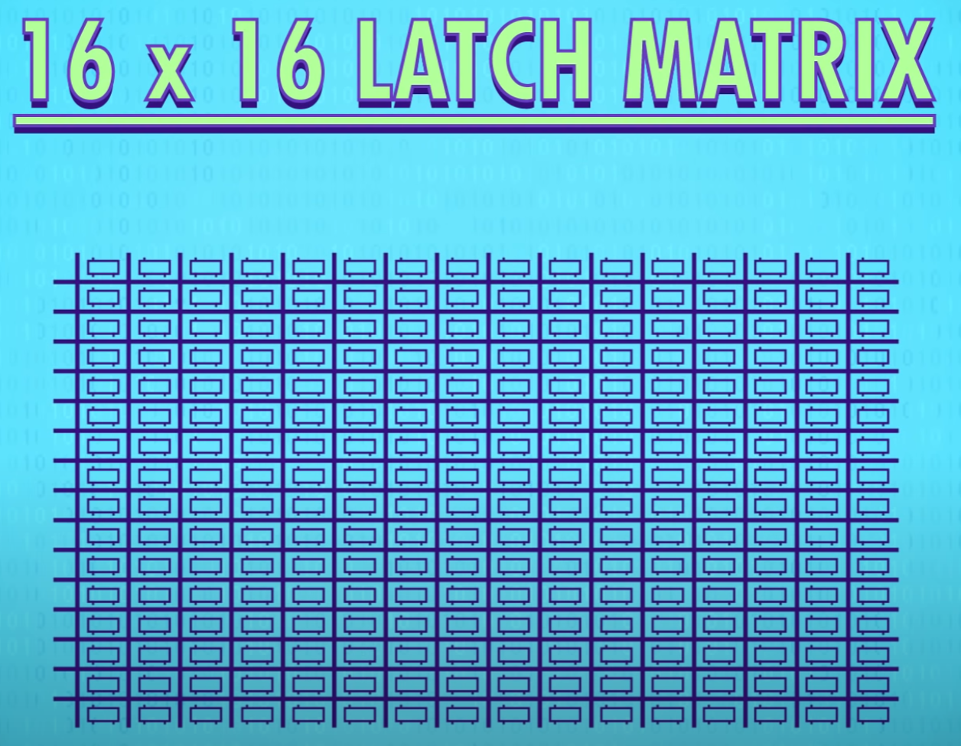

Only one data in is required because only one memory place can be activated at a time

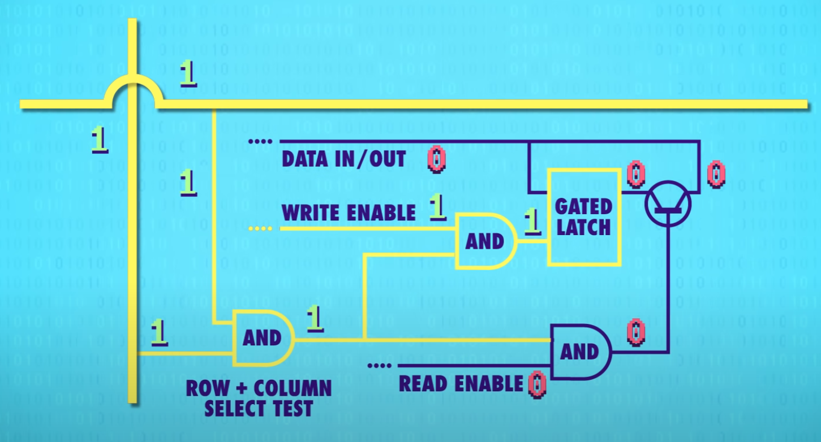

* For 256 bits of data, only 35 wires are needed
* Multiplexer: connects a correct wire according to memory address

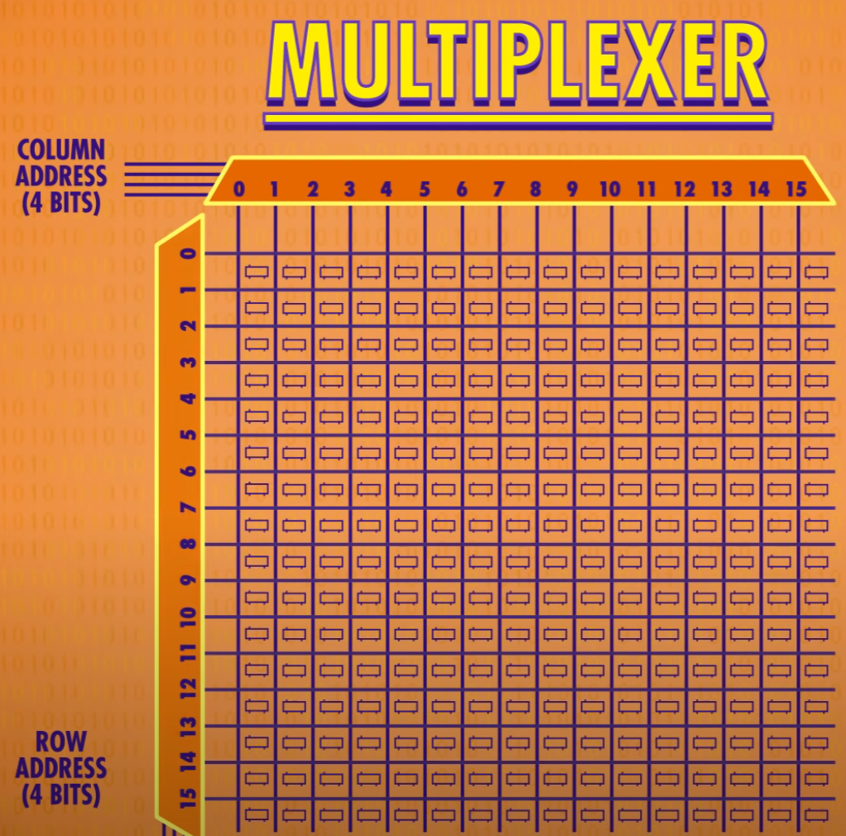

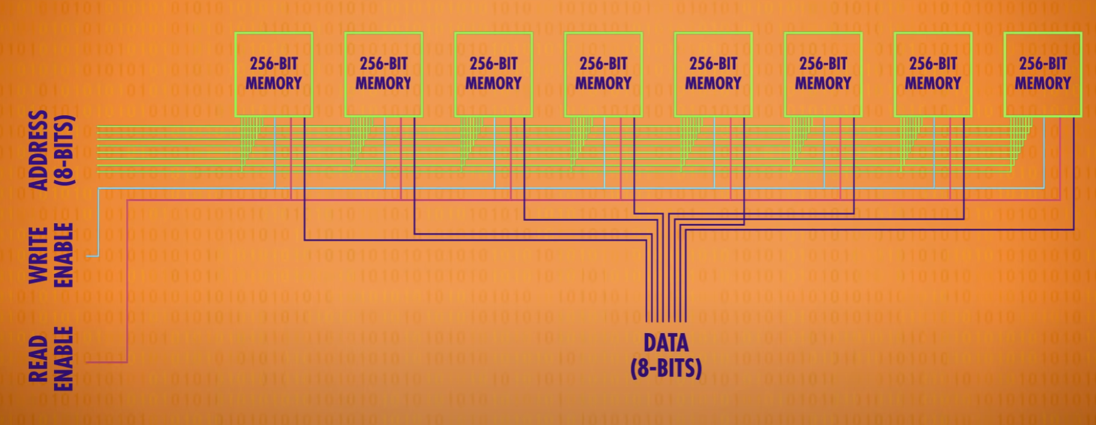

* 1 MB Ram stick

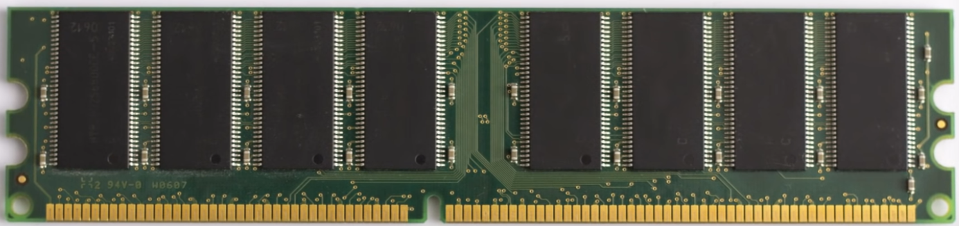

* One of 8 modules

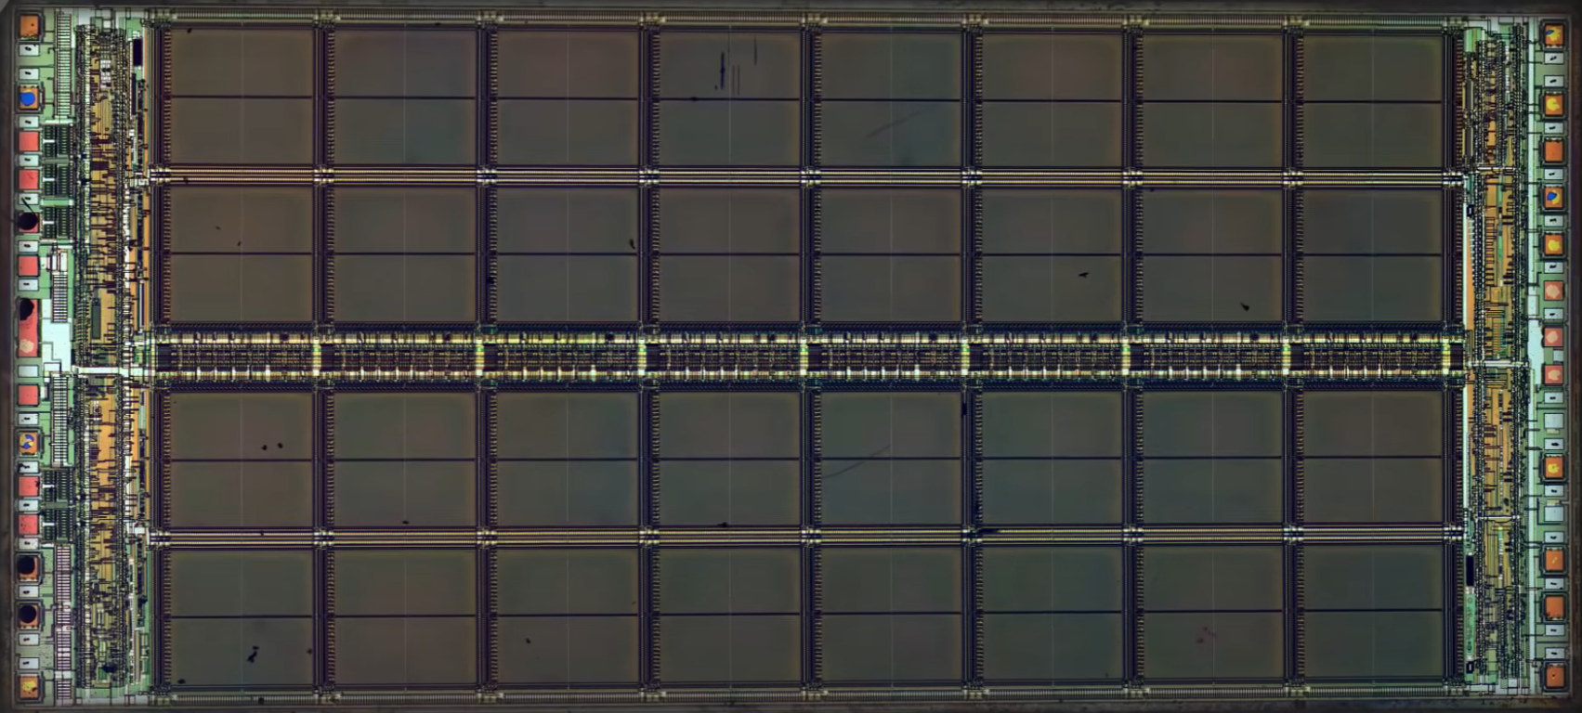

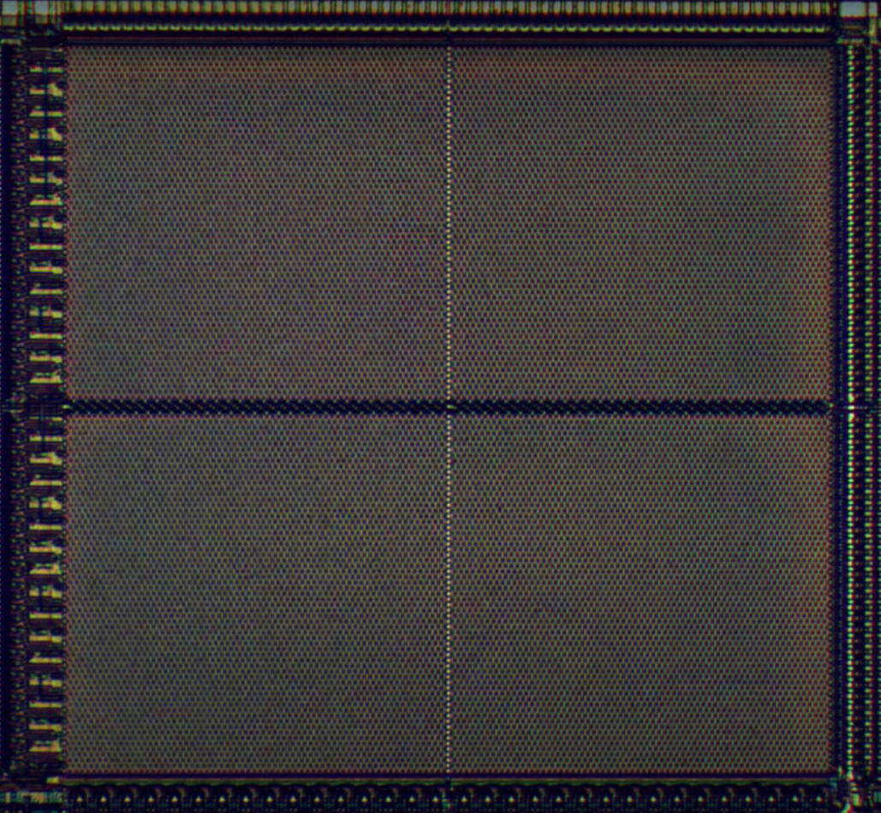

* 128 X 64 bits = 8192 bits



* SRAM: Static Ram, uses latches
* Other types of ram: DRAM, Flash memory and NVRAM: they use other types of circuits and methods.

# 7 The Central Processing Unit (CPU)

* CPU runs instructions
* High level view, Microarchitecture

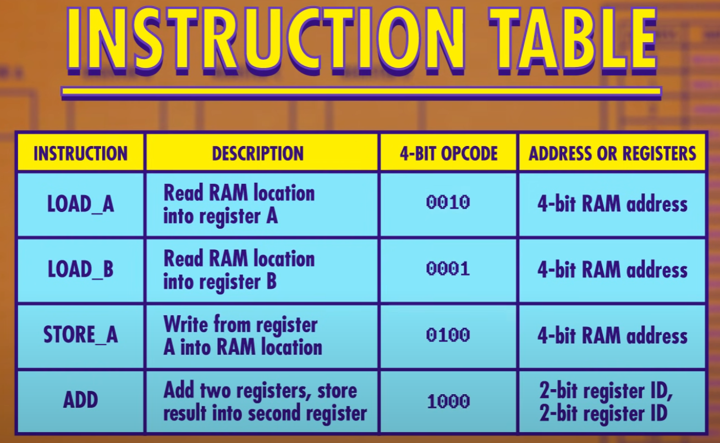

* Instruction address register: where we are in a program
* Instruction register: Current register
* Every register starts at 0
* Fetch phase: retrieve first instruction

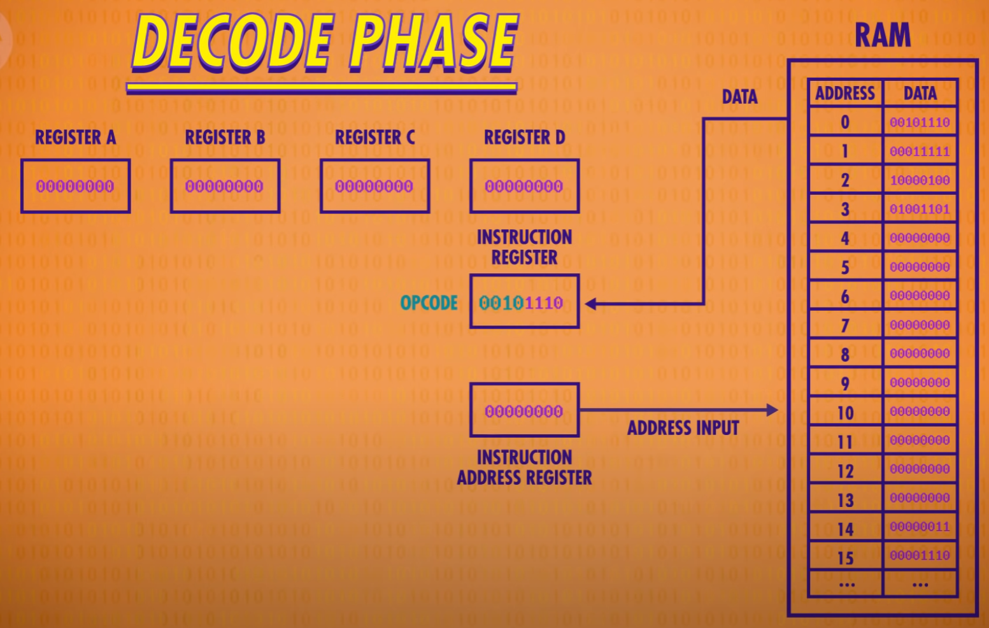

* Instructions are decoded and interpreted by a Control Unit

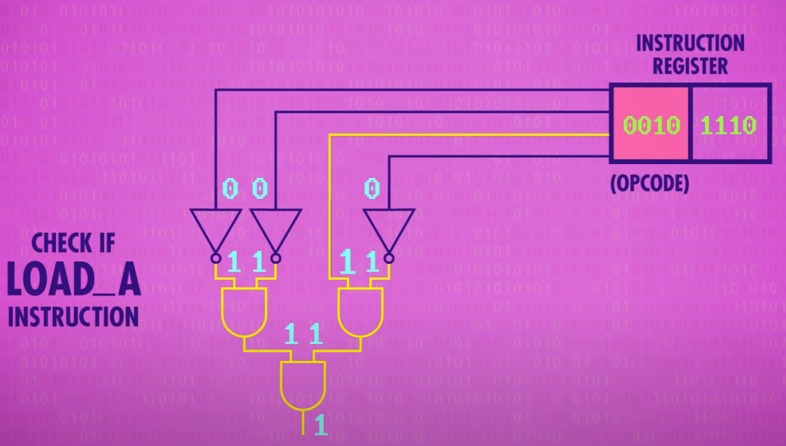

* Excecute phase: Excecute instruction
* Read enabled and fetch by address

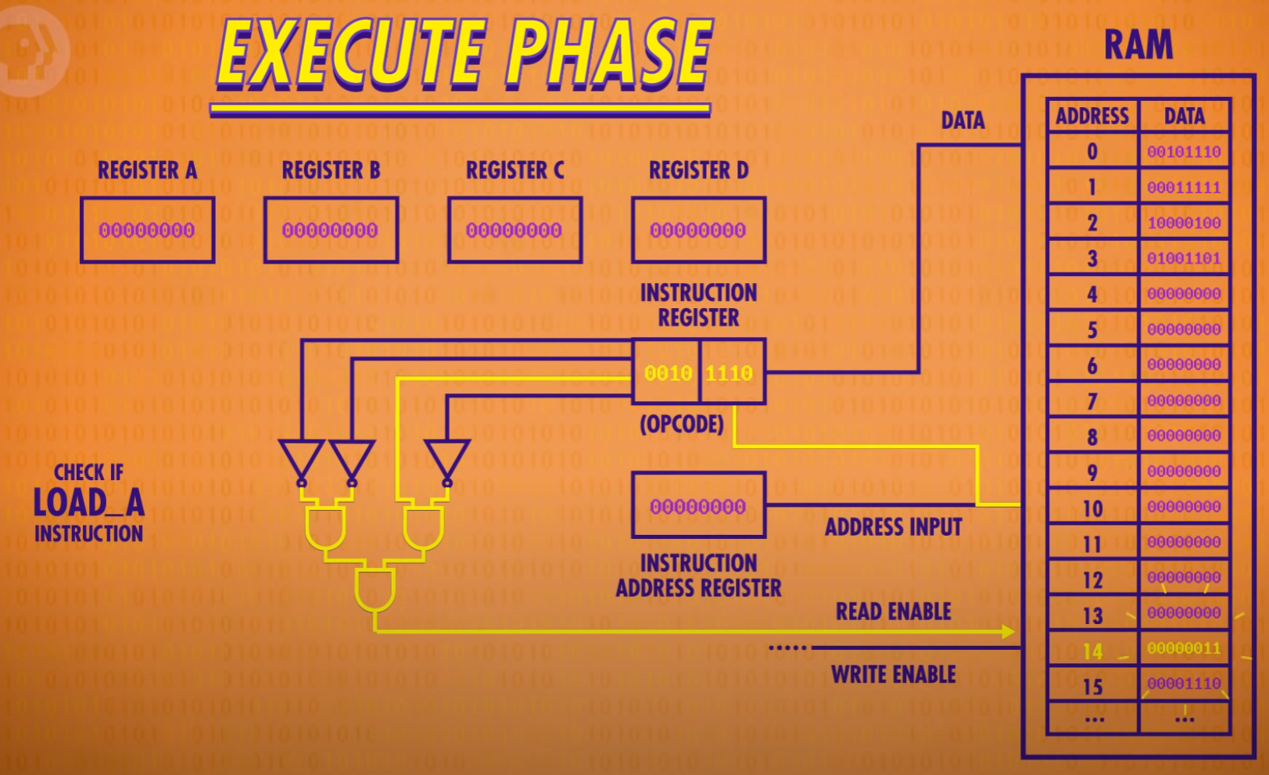

Enable only register A write

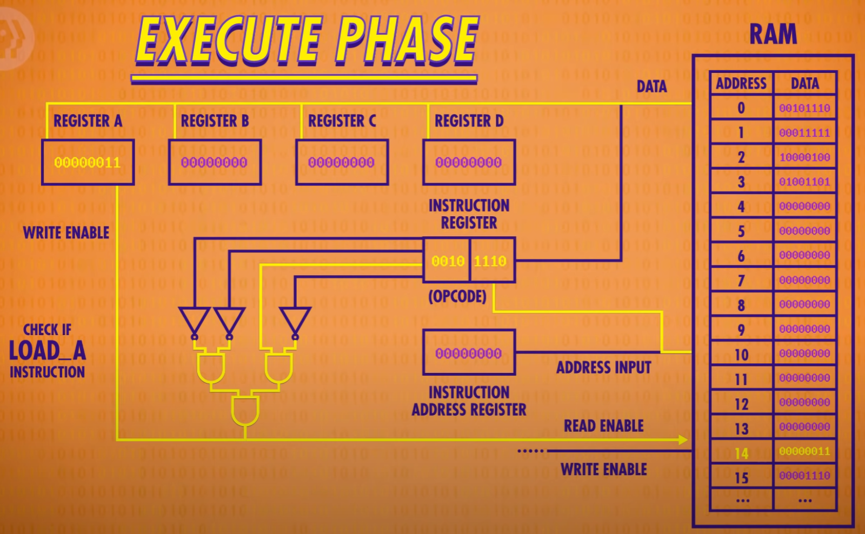

* After excecution, turn off wires and increment Instruction address register by 1

ALU is needed for adding register A and register B

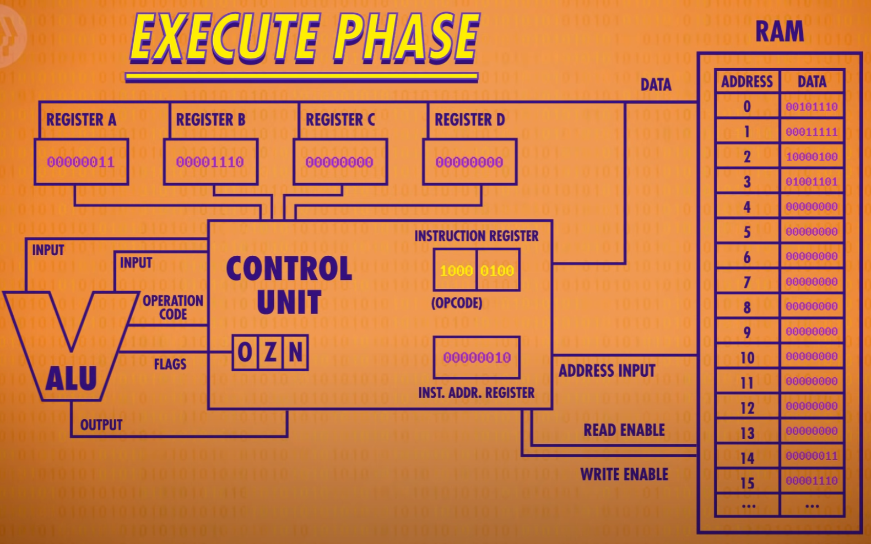

* The Control Unit uses an internal register to temporarily save the output, turh off the ALU, and then write the value into the proper destination register
* The Clock: triggers an electrical signal at a precise and regular interval. Its signal is used by the Control Unit to advance the internal operation of the CPU, keeping everythin in lock-step
* The speed at which a CPU can carry out each step of the fetch-decode-execute cycle is called its Clock Speed: measured in Hertz
* The first single-chip CPU, Intel 4004, 4-bit CPU, 1971: 740 kilohertz

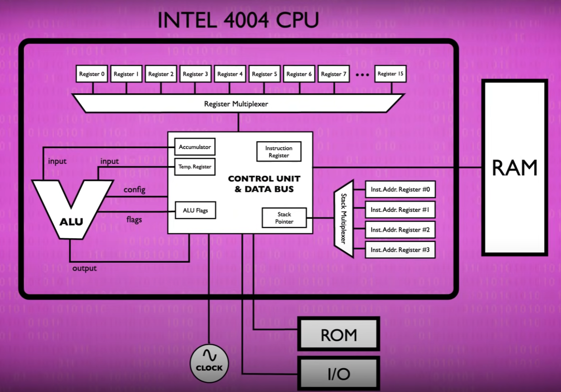

* Overclocking: speed up the clock speed. The CPU might overheat or the signals fall behind
* Underclocking: can save a lot of power
* Moder processors can increase or decrease the clock speed, based on demand: it is called dynamic frequency scaling

# 8 Instructions & Programs

* Hardaware is controlled by Software

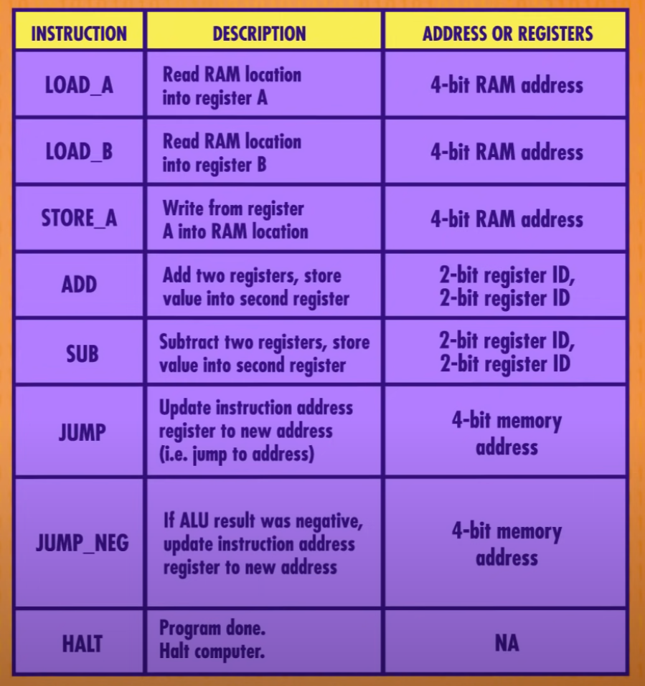

Calculates remainder:

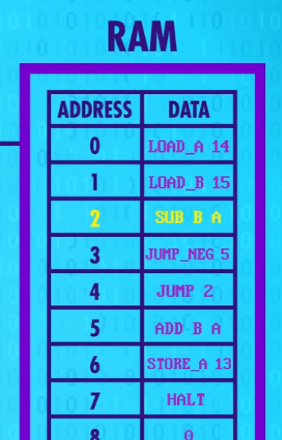

* Instruction length: For example 32-bits or 64-bits
* Variable length instructions: if CPU notices an instruction like JUMP, it knows to fetch also the address to jump to, which is saved immediately behind the JUMP instruction in memory: It’s called Immediate Value: In such processor designs, instructions can be any number of bytes long, which makes the fetch cycle of the CPU a tad more complicated

Example of real instructions:

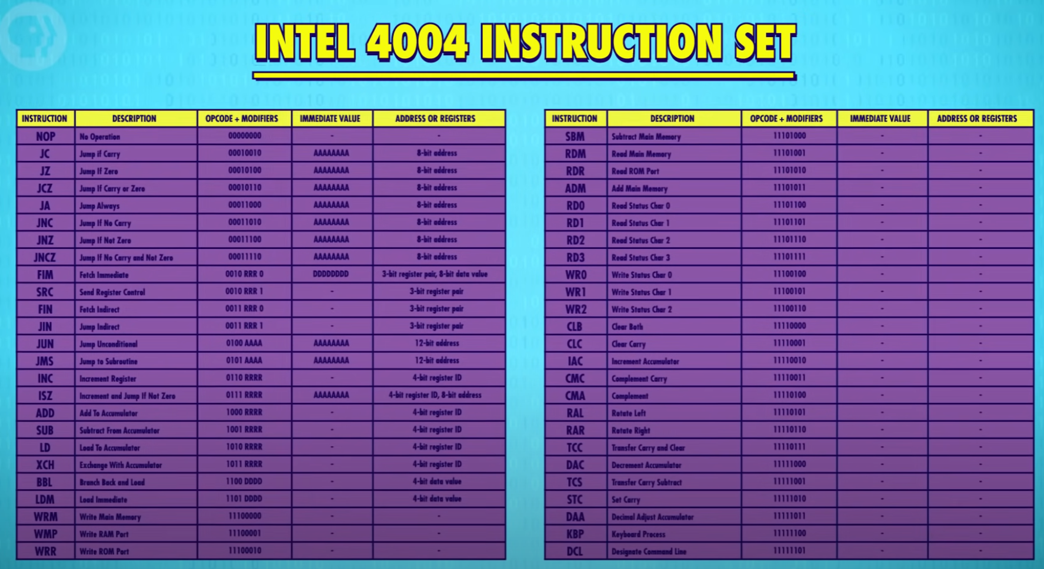

* Modern CPUs have thousands of instructions and instruction values, ranging from 1-15 bytes long. (there’s over a dozens different opcodes just for variants of ADD)

# 9 Advanced CPU Designs

* Modern cpus have special circuits for many things, for example graphics
* Intel 4004 had 46 instructions, and morern cpu tas thousands of different instructions
* A Bus: the data wire between cpu chip and ram
* Cpus have cache, wich is it’s own memory: kilobytes in size: Ram can send several instructions, which are stored in cache
* Cache Hit: data is already in cache --- Cache miss: data is not in cache
* The cache can be used like scatch space, storing intermediate values when performing a longer, or more complicated calculation
* Dirty Bit: a flag in cache for every data not synced with RAM
* Cache is replaced when it is full or when new set of instructions are needed
* Parallelize:

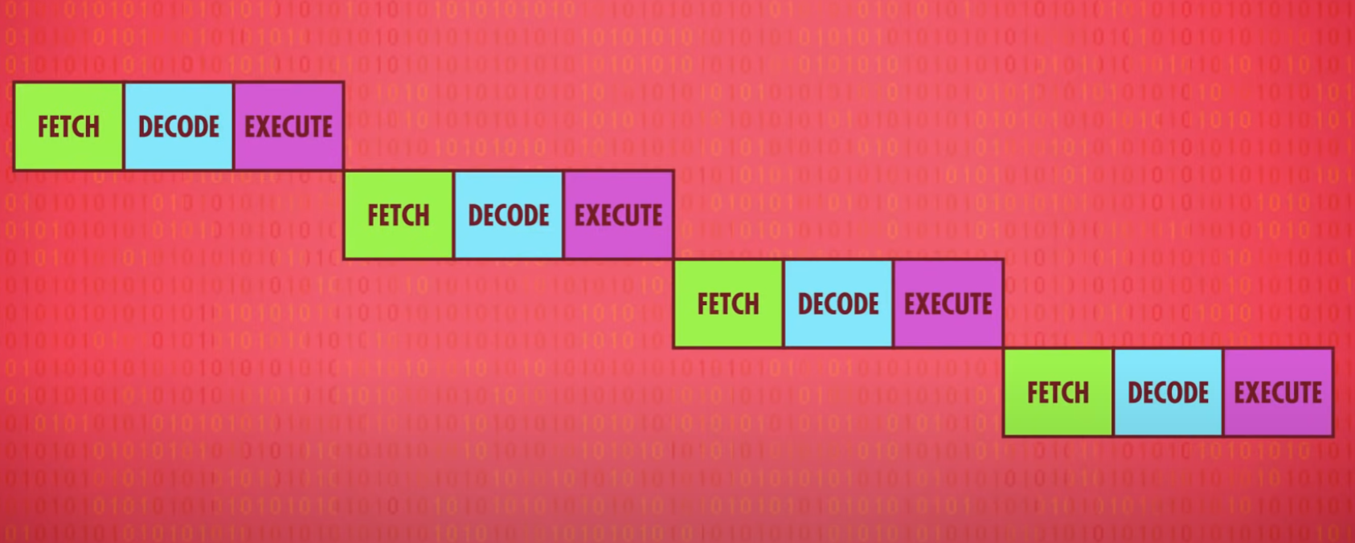 -> 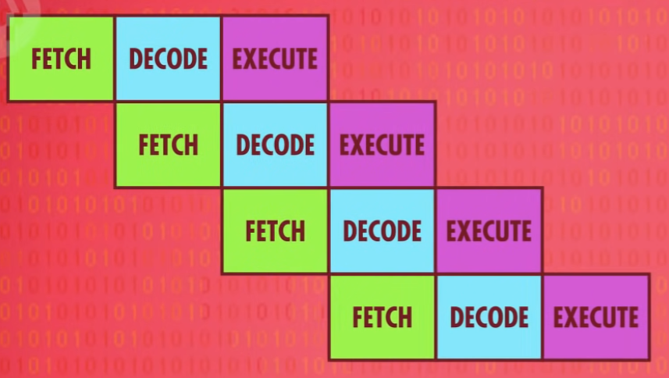

* Pipelining: Searching ahead for data dependencies and if necessary, stall their pipelines to avoid problems.
* Out-Of-Order Execution: Nowdays processors can dynamically reorder instructions with dependencies in order to minimize stalls and keep the pipeline moving.
* Conditional Jump Instructions: These instructions change the execution flow of a program depending on a value. A simple pipelined processor will perform a long stall when it sees a jump instructions, waiting for the value to be finalized: High end processord guess which direction program will go and start filling the pipeline with that information, Speculative Execution. Pipeline Flush: Clear all data from the pipeline (because of the wrong guess)
* Branch Predictions: Instead of being a 50/50 guess, today’s processors can often guess with over 90% accuracy
* Superscalar processors: Can execute more than one instruction per clock cycle. Add more circuitry for popular instructions to increase efficiency. Many cpus have even 8 ALUs.
* Multi-Core processors: cores can use same cache.
* The Supercomputer: The world’s fastest computer(2017) was located in The National Supercomputer Center in Wuxi, China. The Sunway TaihuLight contains 40 960 CPUs, each with 256 cores, each core runs at 1.45 gigahertz. This machine can process 93 Quadrillion floating point math operations per seconds, known as FLOPS.

# 10 Early Programming

# 11 The First Programming Languages

# 12 Programming Basics

# 13 Intro to Algorithms

# 14 Data Structures

# 15 Alan Turing

# 16 Software Engineering

# 17 Integrated Circuits & Moore’s Law

* From 1954s through 1960s, every computer was build with individual parts, Discrete Components, which were all wired together
* 1958, Jack Kilby, working at Texas Instuments, demonstrated an electronic part, where all electronic parts are integrated
* Integrated Circuit, IC: components inside components
* In 1959, Fairchild Semiconductor, lead by Robert Noyce, made Ics practical. Kilby build his Ics out of germanium, a rare and unstable material. Fairchild used silicon(makes about a quarter of earth’s crust). Silicon is also more stable: Noyce is widely regarded as the father of modern ICs.
* Printed Circuit Boards; PCBs: Instead of soldering and bundling up thousands of wires, PCBs, which could be mass manufactured, have all the metal wires etched right into them to connect components together. By using PCBs and ICs together, one could achieve exactly tha same functional circuit as that made from discrete components, but with far fewer individual components and tangled wires. Plus, it’s smaller, cheaper and more reliable.
* Many early ICs were manufactured using tiny descrete components packaged up as a single unit.
* It was hard to get even around five transistors onto a single IC.
* Photolithography: A way to use light to transfer complex patterns to a material, like a semiconductor

# 18 Operating Systems

# 19 Memory & Storage

# 20 Files & File Systems